**DEPT. OF COMPUTER SCIENCE AND ENGG.**

**BIRLA INSTITUTE OF TECHNOLOGY**

**HEART DISEASE PREDICTOR**

A new hybrid knowledge-based system using PRISM classifier and parallel genetic algorithm for diagnosis of heart disease

A project report submitted on the partial fulfilment

of the requirement for the award of the degree

of Bachelors of Engineering in

Computer Science

By : Project Mentor :

**VIBHOR CHATURVEDI BE/10223/2014 DR. B.K. SARKAR**

**RAJAT JAIN BE/10235/2014**

**S. SHREE VIGNESH BE/10242/2014**

**Declaration Certificate**

This is to certify that the work presented in the thesis entitled “ ” in partial fulfilment of the requirement for the award of degree of “Bachelor of Engineering in Computer Science and Engineering of Birla Institute of Technology Mesra, Ranchi” is an authentic work carried out under my supervision and guidance.

To the best of my knowledge, the content of this thesis does not form a basis for award of any previous Degree to anyone else.

(Guide’s Name and Signature)

Dept.Of Computer Science and Engineering, Birla Institute of Technology, Mesra, Ranchi.

**Table of Contents**

1. Objective of the Report
2. Introduction
3. Research Methodology
4. Rule Based Classification
5. Building a Rule Based Classifier
6. Understanding Genetic Algorithms
7. Proposed Methodology (GA)
8. Algorithm for Sequential Genetic Algorithm (SGA) model
9. Code Snippets
10. Samples
11. Result
12. Conclusion
13. Bibliography
14. **Objective of the project**

In the present research, a new hybrid model (integrating PRISM learner and GA) is to be introduced for effective diagnosis of heart disease, addressing the limitations of the existing systems. In particular, the model suggests here a two-level optimization strategy, where *level*-1 first attempts to identify parallelly an *optimal* proportion (Popt) for training and test sets for each Heart dataset using PRISM learner on Cluster-based HPC machine. Next, the best training set (Tbest) for Popt is to be searched again parallelly by the same learner. On the other hand, *level*-2 optimization aims to refine the rule-set(R) generated by the PRISM learner on Tbest by employing parallel genetic algorithm(PGA).

This project consists of two parts, i.e, two levels of optimization. Our part was to carry the project forward with the second level of optimization.

1. **Introduction**

In this project we attempt to develop a model applying sequential genetic algorithms to enhance the performance for application to data sets in the medical domain.

Genetic algorithms are inspired by Darwin's theory about evolution. Solution to a problem solved by genetic algorithms is evolved.

Algorithm is started with a **set of solutions** (represented by **chromosomes**) called **population**. Solutions from one population are taken and used to form a new population. This is motivated by a hope, that the new population will be better than the old one. Solutions which are selected to form new solutions (**offspring**) are selected according to their fitness - the more suitable they are the more chances they have to reproduce.

This is repeated until some condition (for example number of populations or improvement of the best solution) is satisfied.

**2.1 Why the medical domain?**

Heart diseases are and have been very common in elderly people, complicating lives and posing danger. According to 2009 WHO survey, 1 out of every 4 deaths in the world on an average is caused from a heart disease. To get a premature knowledge and understanding of the ailment before it has taken a big form, is an important aspect in its diagnosis. This is why we chose this project so as to help make this world a better place to live in.

**Natural Domain** – Medical Data Sets derive their data from nature and natural occurrences which presents an interesting and pertinent area of work.

**Presence of Conflicts** – Medical Diagnoses are more challenging than regular inferences owing to the fact that a particular set of symptoms can be caused by more than one disease.

**High Dimensionality** – Medical Data Sets are comprised of several factors such as the patient’s history, symptoms, modes of treatment and so on.

**Missing Attributes** – A patient’s data can contain missing fields of information such as the illness history that present a challenge to arriving at a comprehensive analysis.

**Humanitarian Aspect** – Research into improving the efficiency of analyses in the medical domain leads to better healthcare.

1. **Research Methodology**

THE GENERALISED CLASSIFICATION MODEL

MEDICAL DATA

TRAINING DATA

TEST DATA

HYBRID MODEL

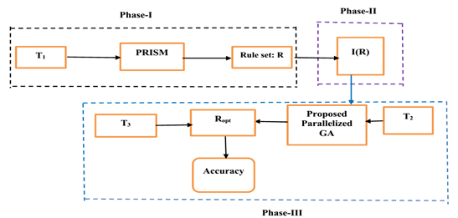

* 1. **Workflow overview of the project**

***Rule-level (level-2) optimization***

*Hybrid model:* (*PRISM+PGA*)

***Data level (level-1) optimization***

· Deciding an *optimal* proportion for training and test sets in parallel manner using PRISM learner

· Finding parallelly the *best* training set for the identified proportion using PRISM learner

1. **Rule based classification**

Rule-based classifier makes use of a set of IF-THEN rules for classification. We can express a rule in the following from −

IF condition THEN conclusion

Let us consider a rule R1,

R1: IF age=youth AND student=yes  
THEN buy_computer=yes

Rule Based Classification is the preferred approach when dealing in the medical domain because of the following reasons :-

* Modularity - Each rule can be seen like a "unit of knowledge".
* Uniformity - All the knowledge is expressed in the same format.
* Naturalness - The rules are a natural format to express knowledge in a domain.

As a result of these, it becomes easier for physicians and experts to express knowledge and diagnoses more naturally which is desirable and advantageous in the medical domain as it leads to simplicity and better readability of data.

1. **Building a rule based classifier**

* This step is the learning step or the learning phase.
* In this step the classification algorithms build the classifier.
* The classifier is built from the training set made up of database tuples and their associated class labels.
* Each tuple that constitutes the training set is referred to as a category or class. These tuples can also be referred to as sample, object or data points.

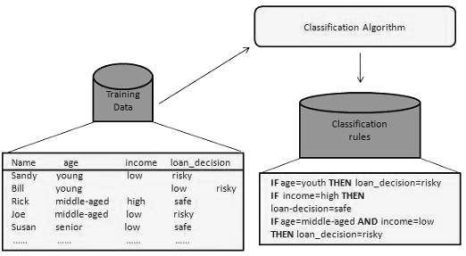

**5.1 Using classifier for classification**

In this step, the classifier is used for classification. Here the test data is used to estimate the accuracy of classification rules. The classification rules can be applied to the new data tuples if the accuracy is considered acceptable.

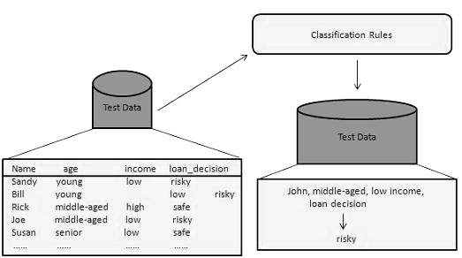

**5.3 Advantages and Disadvantages of PRISM**

ADVANTAGES :-

* It uses rule based classification, and rules are easier to interpret.
* It is easier to implement and understand as compared to other classification algorithms.
* As medical data set is an imbalanced data set, so it is necessary to include all the classes including the minority classes. PRISM

Does not ignore minority classes.

DISADVANTAGES :-

* It does not have rule pruning.
* Better algorithms have been developed but they have implicit knowledge.
* Statistical machine learning methods give better accuracy as compared to PRISM.

**5.4 Why PRISM over Decision-Tree Classifiers ?**

The decision tree output of some classifiers is one of their major weaknesses. Not only can it be incomprehensible and difficult to manipulate, but its use in expert systems frequently demands irrelevant information to be supplied. This report argues that the problem lies in the induction algorithm itself and can only be remedied by radically altering the underlying strategy. It describes a new algorithm, PRISM which uses a different induction strategy to induce rules which are modular, thus avoiding many of the problems associated with decision trees.

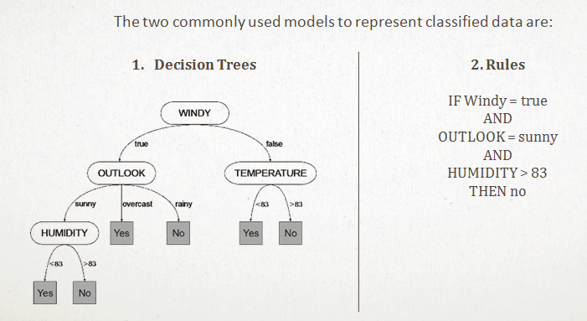

**5.5 PRISM Algorithm**

**Input**: Initialize examples (E) to the training set (T).

*For*  each class *c,*

*While*  T contains examples of class c

* Create a rule *r* with an empty left-hand side (LHS) that predicts class c

*Until* *r* is perfect (or there are no more attributes to use) *do*

*For*  each attribute: *A*  not mentioned in *r* , and each value *v*,

* Consider adding the condition A = v to the LHS of *r*
  + Select *A* and v to **maximize** the  *accuracy* **p/t** , where p= number of instances covered by rule that belong to the positive class and  *t=* number of instances covered by rule (r)

(*break ties by choosing the condition with the largest p*)

* + Add A = v to r
  + Remove the instances covered by *r* from T

**5.5.1 Input Design**

DATA

INSTANCES

I2

I1

I0

C0

A0

C1

A1

C2

A2

ATTRIBUTES

CLASSES

ATTRIBUTE VALUE SETS

AV2

AV1

AV0

V0

VALUES

V1

V2

**5.5.2 PRISM Design**

PRISM

PRISM RULE 3

PRISM RULE 2

PRISM RULE 1

RULE TEST 1

DATA

RULE TEST 2

**5.6 Level – I (Detailed Workflow)**

* Once the number of processors to be used has been determined, the splitter splits the dataset into n sets of <Training data, Test data>.
* The Training data for each is then fed to the PRISM algorithm as input, in parallel.
* Following this, each processor writes the rules using the interface writer to the interface.
* The accuracy model then uses these rules in combination with the test data to determine the accuracy for each.
* The best result i.e., the one with the greatest accuracy is chosen.

1. **Understanding Genetic Algorithms**

Genetic algorithms are inspired by Darwin's theory about evolution. Solution to a problem solved by genetic algorithms is evolved.

Algorithm is started with a **set of solutions** (represented by **chromosomes**) called **population**. Solutions from one population are taken and used to form a new population. This is motivated by a hope, that the new population will be better than the old one. Solutions which are selected to form new solutions (**offspring**) are selected according to their fitness - the more suitable they are the more chances they have to reproduce.

This is repeated until some condition (for example number of populations or improvement of the best solution) is satisfied.

**6.1 Outline of basic genetic algorithm**

1. **[Start]** Generate random population of *n* chromosomes (suitable solutions for the problem)
2. **[Fitness]** Evaluate the fitness *f(x)* of each chromosome *x* in the population
3. **[New population]** Create a new population by repeating following steps until the new population is complete
   1. **[Selection]** Select two parent chromosomes from a population according to their fitness (the better fitness, the bigger chance to be selected)
   2. **[Crossover]** With a crossover probability cross over the parents to form a new offspring (children). If no crossover was performed, offspring is an exact copy of parents.
   3. **[Mutation]** With a mutation probability mutate new offspring at each locus (position in chromosome).
   4. **[Accepting]** Place new offspring in a new population
4. **[Replace]** Use new generated population for a further run of algorithm
5. **[Test]** If the end condition is satisfied, stop, and return the best solution in current population
6. **[Loop]** Go to step 2

**6.2 Genetic Operators**

Selection, crossover and mutation

As you can see from the [genetic algorithm outline](http://www.obitko.com/tutorials/genetic-algorithms/ga-basic-description.php), the crossover and mutation are the most important part of the genetic algorithm. The performance is influenced mainly by these two operators

* **Selection of rules** : As we already know from the [GA outline](http://www.obitko.com/tutorials/genetic-algorithms/ga-basic-description.php), chromosomes are selected from the population to be parents to crossover. The problem is how to select these chromosomes. According to Darwin's evolution theory the best ones should survive and create new offspring. There are many methods how to select the best chromosomes, for example roulette wheel selection, Boltzman selection, tournament selection, rank selection, steady state selection and some others.
* **Crossover (Reproduction operator)** :
  + **Single point crossover** - one crossover point is selected, binary string from beginning of chromosome to the crossover point is copied from one parent, the rest is copied from the second parent

**11001**011+11011**111** = **11001111**

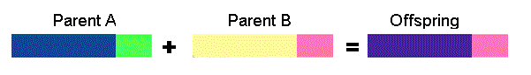

* **Two point crossover** - two crossover point are selected, binary string from beginning of chromosome to the first crossover point is copied from one parent, the part from the first to the second crossover point is copied from the second parent and the rest is copied from the first parent

**11**0010**11** + 11**0111**11 = **11011111**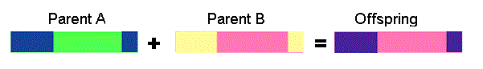

* **Mutation :**

Bit inversion - selected bits are inverted

**11001001 => 10001001**

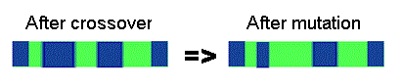

**6.2.1 Fitness Function**

A fitness function is essentially an objective function for any problem, and it depends upon the nature of the problem. The function gives a means of evaluating a solution for its inclusion in the resulting set. From the perspective of decision making, factors such as *prediction*-*accuracy*, *error* (i.e., misclassification) *rate*, *true positive rate*, etc. are essentially considered for constructing fitness function.

1. **Proposed Methodology**

Best dataset classified using rule based induction (PRISM Algorithm

Sort all species according to their fitness values and pick the topmost n species.

Repeat for 1000 times

After m iterations

Encoding and creation of population

Calculation of fitness values of species new offsprings

Repeat for m times

Selection of two random species

Decoding

Two point crossover

Mutation

**7.1 Encoding Scheme :**

From the chosen discretized heart datasets, it has been observed that the largest value of any attributes among all the datasets does not exceed 7. Hence, 3 bits are sufficient to encode each attribute. Accordingly, 3x13=39 bits in total are necessary to represent every rule of the datasets, viz., Heart(Cleveland), Heart(Hungarian) and Heart(Swiss), since each of these databases has total 13 attributes (including) the class attribute. However, this size becomes 3x14=42 bits for Heart(Statlog) because this set contains total 14 attributes (including the class attribute).

As per this representation, if ‘*’ appears in a rule for an attribute, then this symbol is simply encoded as: 000. On the other hand, an equivalent binary coding is adopted for values other than ‘*’. This technique is undoubtedly one of the easiest implementation techniques for encoding the rules.

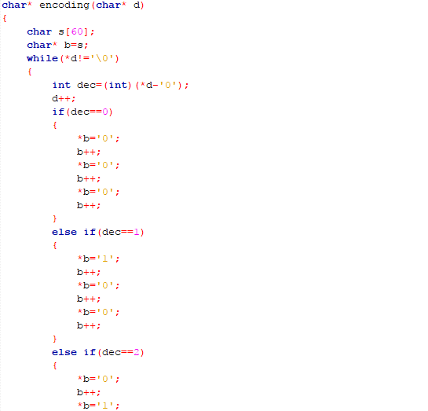

**7.2 Selection :**

In this research, the selection of parents for performing *crossover* is made at random. Here, the rules in the rule set (*i.e*., population) are numbered as: 1, 2, . . ., *n.* Now, two parents say: p1and p2 are picked *randomly* from the current rule set with *n* rules, and placed them into a mating pool (say M). Thus, the probability of a selecting rule in a rule set (with *n* rules) is:

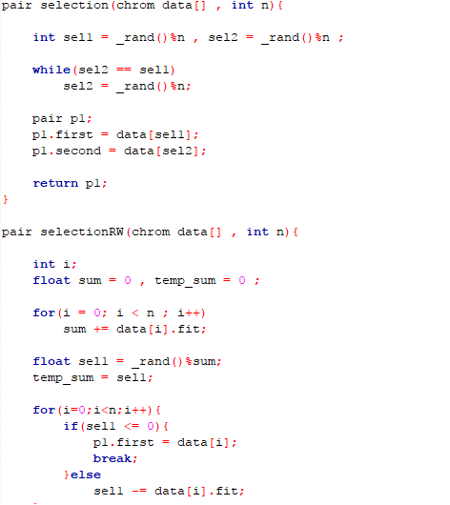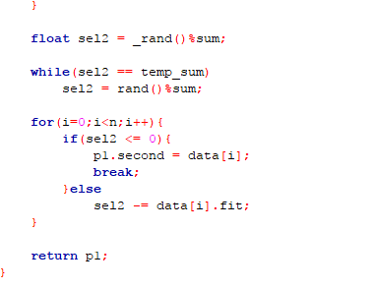

**7.3 Crossover :**

The present study performs two-point cross-over technique, where two distinct points: xi (i = 1, 2) are again chosen *randomly* within 1 < xi < L. Finally, the heads and tails (the parts respectively before and after the cutting points) of the parents are swapped. Obviously, probability (pc) of selecting any crossover point is : 1/L.

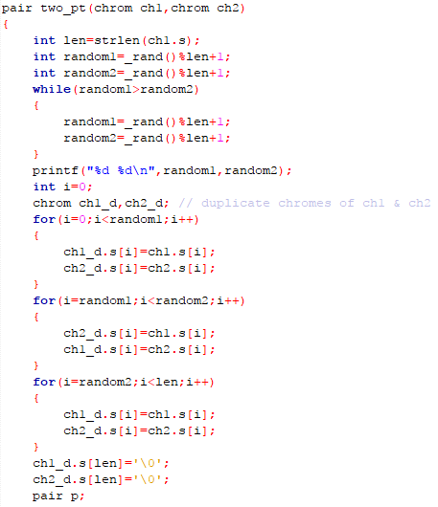



**7.4 Mutation :**

As per the basic concept of mutation operation in GA, a zero (‘0’) is changed to one (‘1’) and vice versa for a binary coded solution. Here, single point mutation (selected at random within the length L) is performed after crossover. Thus, pm(probability of selecting any mutation point) is 1/L . Now, the above mentioned three steps combinedly result two new individuals: say O1 and O2.

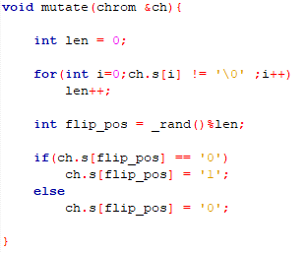

**7.5 Decoding Scheme :**

We know that decoding is the reverse process of encoding. The decoding strategy adopted in the present study is briefly stated below. In particular, the following steps are applied during decoding.

Step-1: Access the binary stream block by block, each of size 3 bits.

Step-2: For each block, the value *v* is computed as the decimal equivalent of that stream.

Step-3: *If v*=0, *then* place ‘*’ at the position of the attribute corresponding to its block, (except for the target attribute)

*else* *if* (v > amax), *then* place the scaled value vs  = ceil( vs/amax) at that position, where *a*max  denotes the *maximum* value yield by that attribute, *else* place simply the computed value at that position.

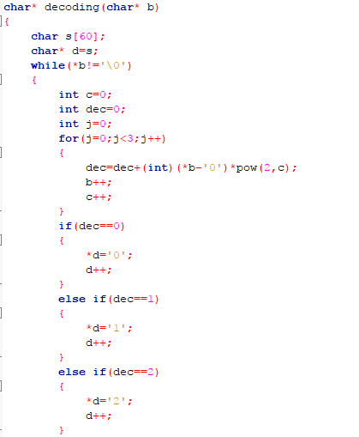

**7.6 Fitness Function :**

Keeping the point in mind that the heart databases are imbalanced in nature, *fitness function* for measuring fitness value of each rule (*r* ) in rule set (I(R))

**f(r) =( ( m - n ) / nci ) + ( 1/k )**

,where *m*  and *n* represent respectively the numbers of training examples *correctly* and  *incorrectly* classified by *r* over T2. Further, *k* represents the number of *pre-conditions* present in the rule *r* and nci is the number of examples of class *ci* present in T2 such that the class-label of rule *r* is also *ci*.

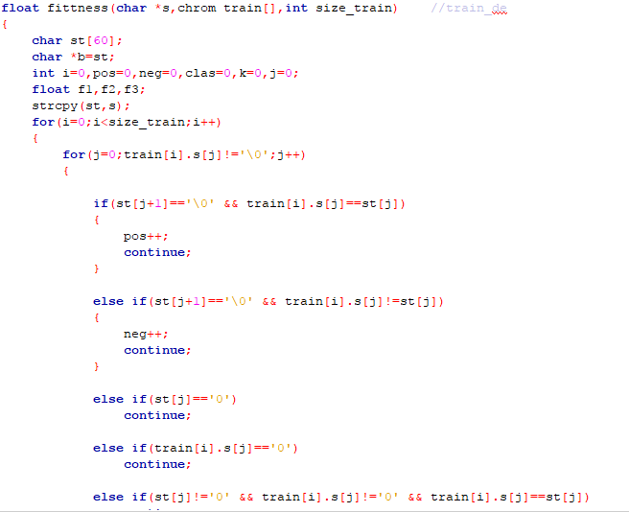

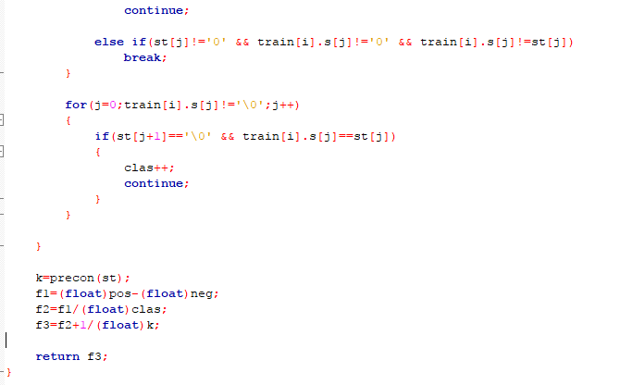

1. **Algorithm used for the SGA model :**

*Variable*: R: rule set where each rules in ‘IF- THEN’ format

I(R) : Rule set (R) in tabular form

O1, O2, r1, r2 : rule of I(R) format

ctr = 0, Max_itr // Max_itr says the *maximum number of iterations*

*Step*-1 Randomly selects two rules (solutions), say r1 and r2 from I(R)

*Step*-2: Apply the suggested *two-point* crossover and then *mutation* points on r1 and r2 to result two new *distinct* offspring: O1 and O2 (in decoded form).

*Step*-3: Check the *rule-redundancy* and *rule-conflict* cases for each of Oi (*i* =1, 2) with the rules present in R following the strategy presented in the next section, and take action(s) appropriately.

*Step*-4: If Oi (i=1, 2) is correct (*i.e*., neither redundant nor conflict), then evaluate fitness score of each Oi (i=1, 2).

*Step*-5: Choose the best rule (rbest) based on fitness score over T2.

*Step*-6: Replace the worst rule: rworst with the rbest  if possible.

*Step*-7: ctr =ctr +1. If (ctr < Max_itr), then goto Step-1.

**8.1 Managing redundant and conflicting rules:**

**8.1.1 Managing Redundant Rules :**

Two rules: r1 and r2 are identical if *min* (|pre(r1)|, |pre(r2)|) = *match*(pre(r1), pre(r2)), where |pre(*ri*)| results the number of *pre-conditions* (each with a numerical value) present in rule: *ri*and the function: *min*(m1, m2) returns the *minimum* between two numbers: *m1, m2*.

Let r1 and r2 be two decision rules for P as follows:

· r1: *If* (A1=4) *and* (A2= 2)  *and* (A4=1), *then*  C=1

· r2:  *If* (A1=4) *and* (A4=1), *then* C=1

The number of pre-conditions present in r1 is 3, whereas it is 2 in r2. In fact, the rules *match*  at *two* places except for (A2=2) in r1. Clearly, the number of *matched* pre-conditions (*m*) is here 2 (*i.e*.,*m* =2). Again, *min* (|pre(r1)|, |pre(r2)|)= *min*(3,2) returns 2, and it equals to *m*.

Hence, both the rules are *identical* but one supersedes the other. In other words, out of these two rules, one is the *super* rule of the other. It is observed that |pre(r2)| =2 , and it is *less* than |pre(r1)|=3. So, rule r2 is here treated as the *super* rule of r1, and r2 (instead of r1) is well expected to be present in rule set with the aim to classify more *test* examples. Definitely, r1 is *redundant*, and it is to be removed from rule set, R.

**8.1.2 Managing Conflicting Rules :**

Two rules are termed as *conflict* rules if their antecedent parts are  *identical* but consequent parts (*i.e.,* class values) are *different*. For better realization, let *r*1 and *r*2 be two rules of P as:

· r1: *If* (A1=4) *and* (A2= 2)  *and* (A4=1), *then*  C=1

· r2:  *If* (A1=4) *and* (A2= 2)  *and* (A4=1), *then*  C=2

Clearly, these two rules present an example of conflict rules, since their *antecedent* parts are same but class values are different (*i.e*., these are C=1 and C=2 respectively). Now, if r1 and r2 are *conflict*, then keep the rule with maximum prediction rate on T2 and discard the other.

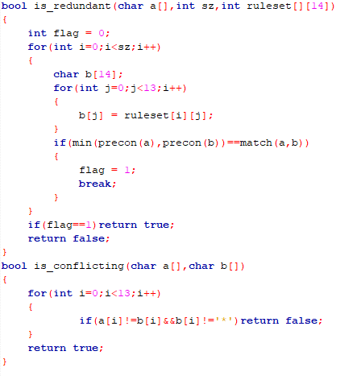

1. **Code Snippets**

**9.1 Reading dataset from file**

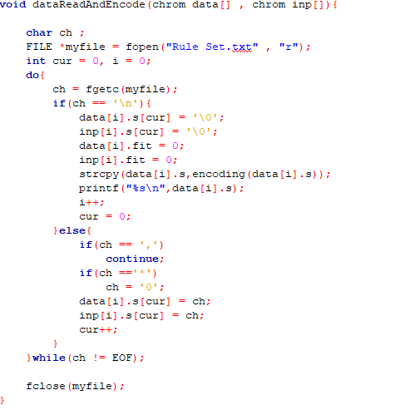

**9.2 Random selection operator in C**

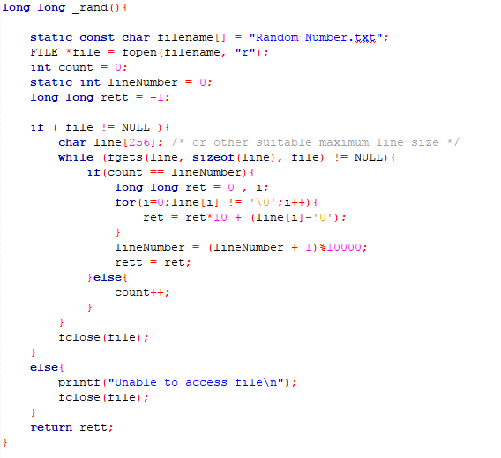

**10. Samples**

heart_data

1,2,2,2,1,2,1,3,1,1,1,1,1,0

2,1,3,2,3,2,3,2,1,1,1,2,1,0

2,2,3,2,1,2,1,3,1,1,1,2,3,0

2,2,1,2,2,2,3,2,1,3,3,1,2,0

2,2,2,2,2,1,3,1,1,1,1,1,1,0

2,1,4,1,1,1,1,1,1,1,1,3,1,0

2,2,2,2,2,1,1,3,1,1,1,1,1,0

2,2,2,2,1,2,3,1,1,1,1,1,1,0

2,2,4,2,3,1,3,2,1,1,2,1,1,0

1,1,3,2,1,1,1,3,1,1,2,1,1,0

1,1,3,2,3,2,1,3,1,1,1,1,1,0

1,1,3,2,1,1,1,2,1,1,1,2,1,0

2,1,3,2,3,1,1,3,1,1,1,2,1,0

heart_ruleset

*,*,*,*,*,*,*,3,*,*,*,*,1,0

*,*,3,*,*,*,*,*,*,*,*,*,1,0

*,*,1,*,1,*,*,*,*,*,*,*,*,0

1,*,2,*,*,*,*,*,*,*,*,*,*,0

*,*,*,*,2,*,3,*,*,*,*,*,*,0

*,1,3,*,*,*,*,*,*,*,*,*,*,0

*,*,*,*,*,*,1,*,*,*,*,*,1,0

*,1,*,*,*,*,*,*,*,*,*,2,*,0

*,*,*,*,*,*,*,*,*,2,*,*,2,0

1,*,*,*,*,*,*,1,*,1,*,*,*,0

*,*,*,*,*,*,*,*,*,*,*,2,3,1

*,2,*,*,*,*,*,*,*,*,*,3,*,1

*,*,*,*,*,*,*,*,*,*,2,4,*,1

*,*,2,*,*,*,*,*,*,*,*,*,3,1

*,*,4,*,*,*,*,*,*,3,*,*,*,1

*,*,4,*,*,2,*,*,*,*,*,*,*,1

*,*,*,*,*,2,*,*,*,*,*,*,3,1

*,*,4,*,*,*,*,*,1,*,*,*,3,1

*,*,*,*,*,*,*,*,*,*,*,2,2,1

*,*,4,*,*,*,*,*,*,2,*,*,3,1

*,*,1,*,3,*,*,*,*,*,*,*,*,1

2,*,4,*,3,*,*,*,*,*,*,1,*,1

1. **Result :**

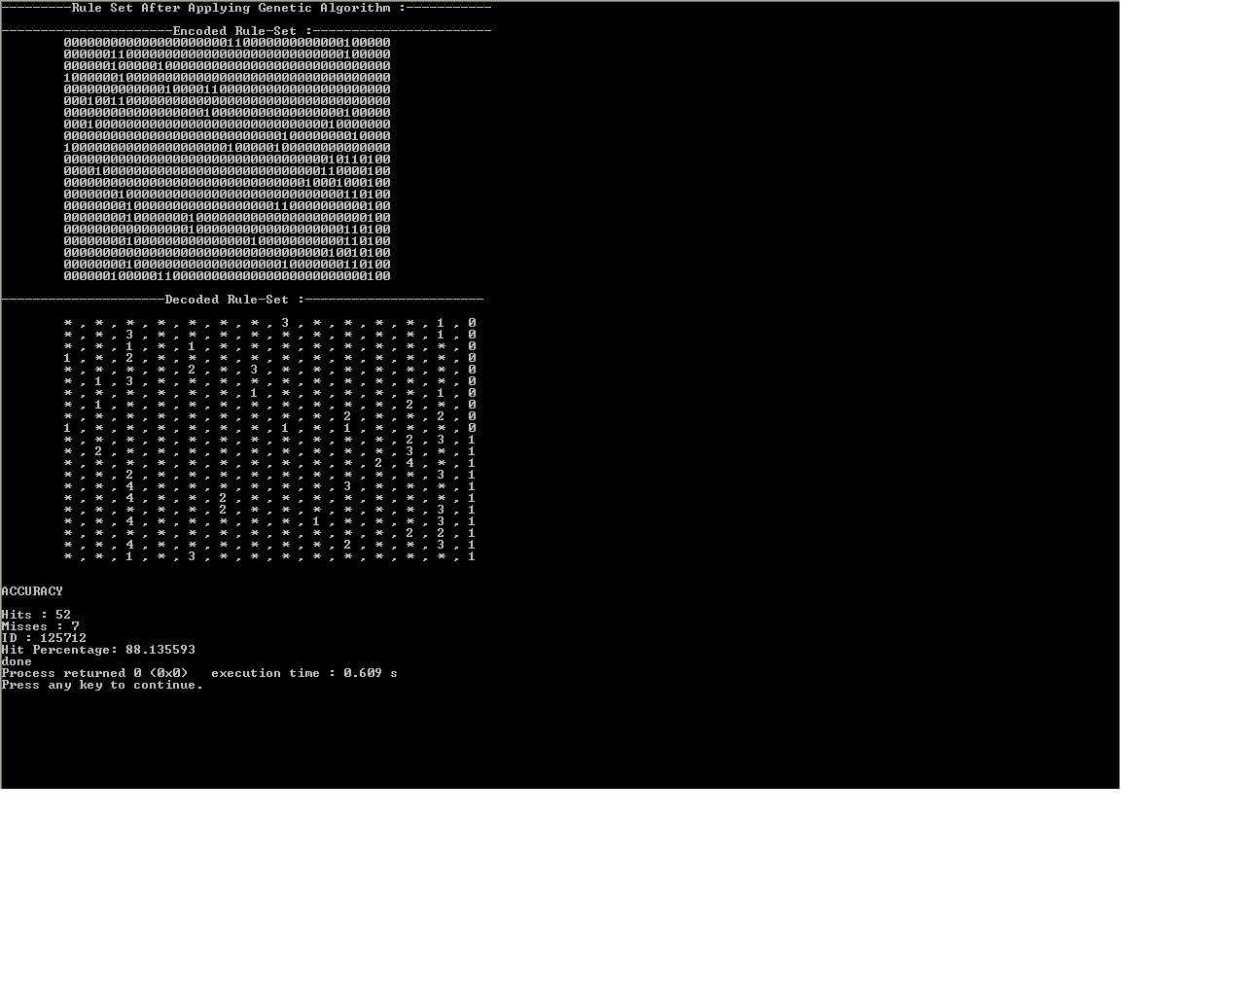

1. **Conclusion :**

By applying genetic algorithm on the classified dataset, an accuracy of **88%** was achieved, compared to **less than 70%** previously.

**Future prospective :** Moving forward with the same project, we will try achieving parallelism and thus enhancing the efficiency multifolds.

**13. Bibliography :**

[1] **Jadzia Cendrowska**, C/O The Faculty of Mathematics, The Open University, Walton Hall, Milton Keynes, MK7 6AA, U.K. (29/05/1987)

[2] **Issa Qabajeh**, **Francisco Chiclana**, Centre for Computational Intelligence, De Montfort University, UK; **Fadi Thabtah**, EBusiness Dept, CUD, Dubai (UAE) : A Classification Rules Mining Method based on Dynamic Rules' Frequency (2015)

[3] Article on Malnutrition Detection and Management System

[4] **J. Han, M. Kamber**, Data Mining: Concepts and Techniques, Elsevier Inc..

[5**] I. H. Witten and E. Frank**, Data Mining: Practical Machine Learning Tools and Techniques, 2nd Rule-Based Classification Edition, Elsevier Inc., 2005

[6] **Marek Obitko**: Genetic Algorithm Library, <https://www.codeproject.com>

[7] **Johannes Furnkranz**, Separate-and-Conquer Rule Learning, Austrian Research Institute of Artificial Intelligence, 3-54, 1999